|  |  |
| --- | --- |
| **CSL2070 Digital Design**  Lab Report | |
| **Roll Number** | **B20CS029** |
| **Name** | **Kulkarni Tanmay Shreevallabh** |
| **Lab number** | **Lab3** |
| **Experiment Title** | **BCD Adder, BCD Subtractor, Binary Multiplier (3Bit)** |

**Adder-Subtractor**

**Circuit Diagram**

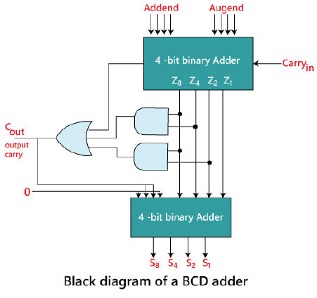

**Code**

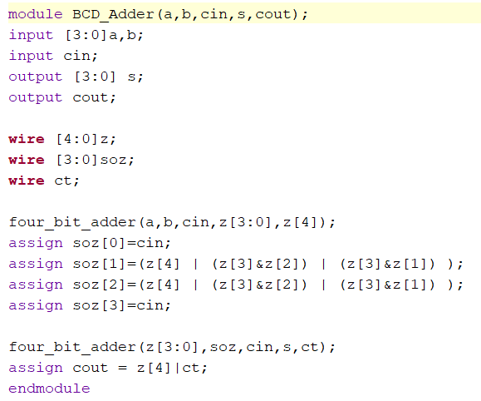

**Code for Test Bench  
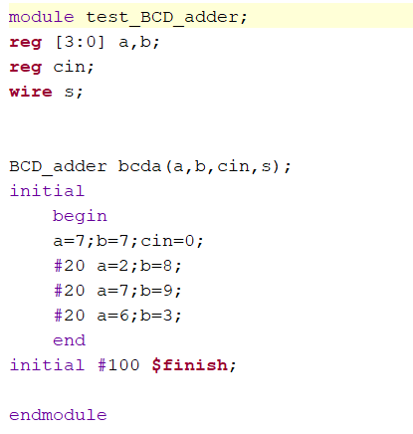**

**Waveform**

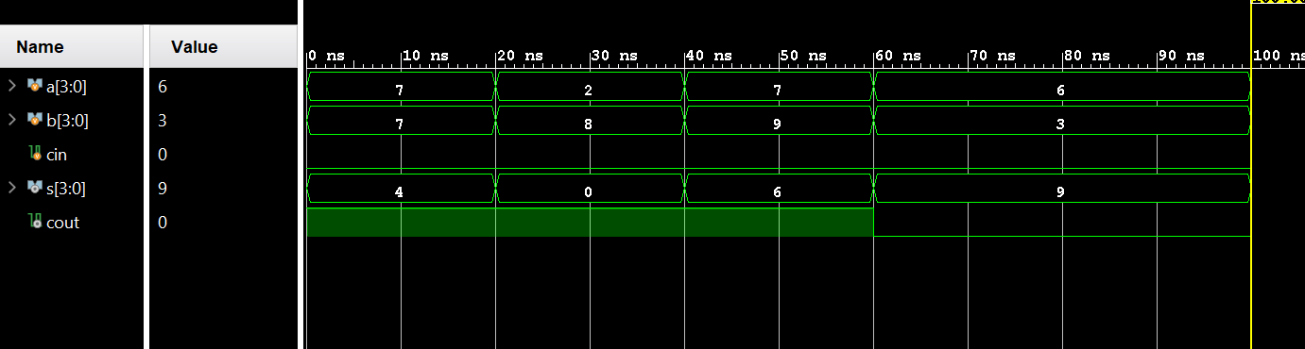

**BCD Subtractor**

**Circuit Diagram**

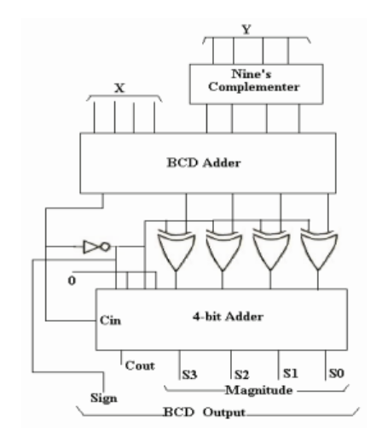

**Code**

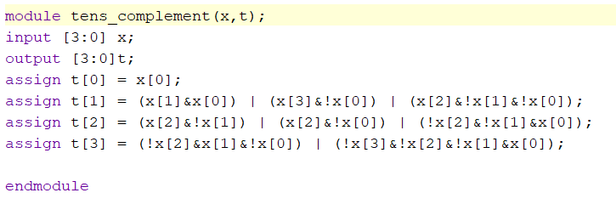

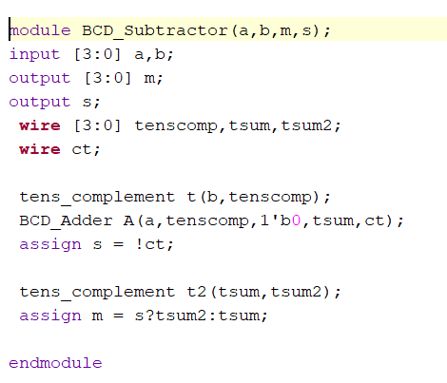

**Code for Test- Bench**

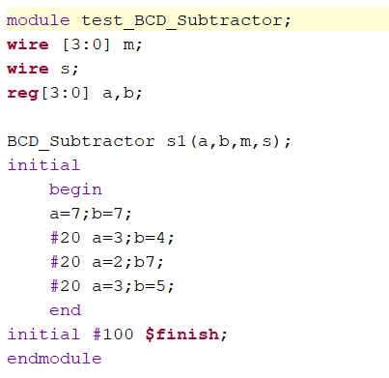

**Waveform**

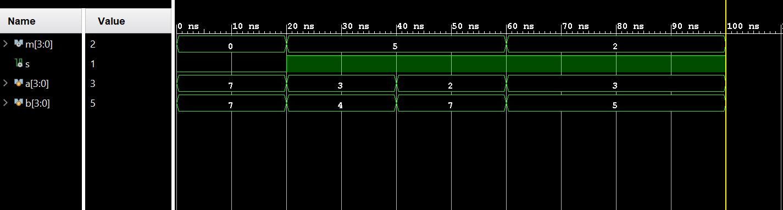

**3-Bit Multiplier**

**Code**

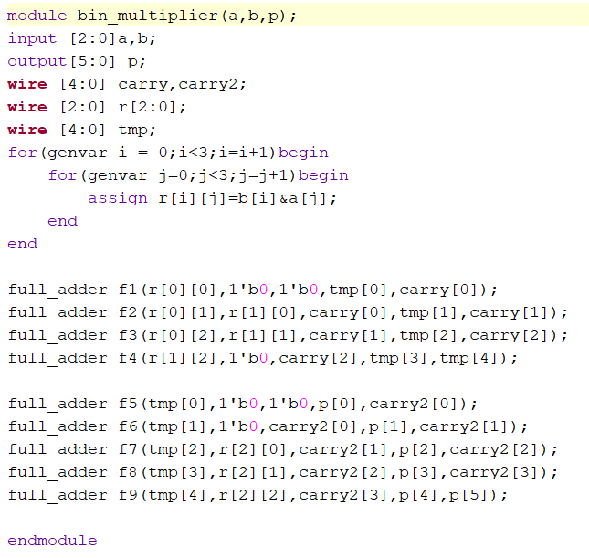

**Code for Test- Bench**

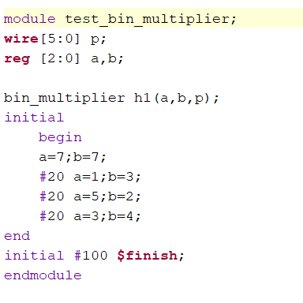

**Waveform**

